ALL FORMS OF ORIGINAL ART

MArteLive Europe
a European contest and festival supported by the Creative Europe Programme of the European Union

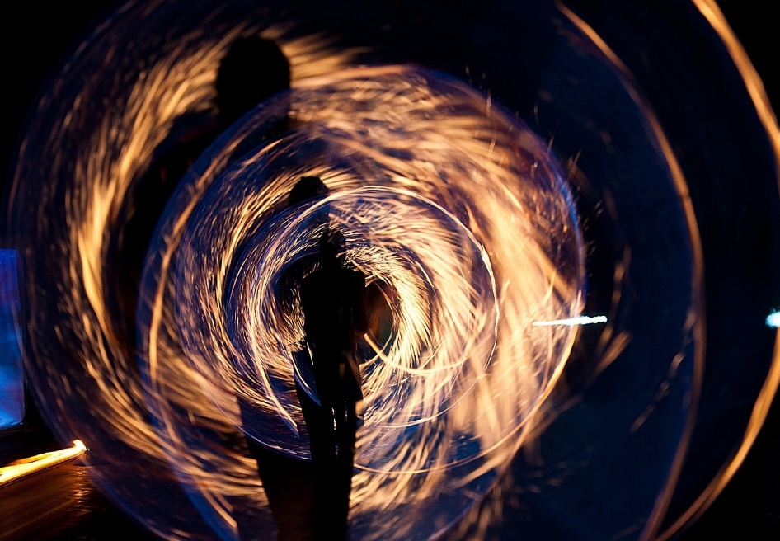

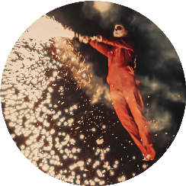
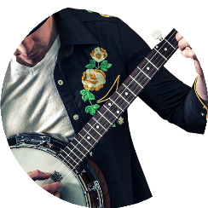
MArteLive - A lifetime opportunity

MArteLive Europe supports and nurtures young and emerging artists.

Dedicated to the dissemination and blossoming of original arts and young talents.

More info:
www.martelive.eu www.martelive.de
Celebrating Art, Music and Culture in all its forms!
- Are you between 18 and 35 years old?
- Are you a European citizen and /or resident?
- Are you an artist in one of our 16 artistic disciplines?

Then don’t miss this once in a lifetime opportunity!

Gain international exposure, network with fellow artists and high professionals, live the unforgettable experience of an Art Residency, win attractive prizes, featuring and collaborations - and win a ticket to Rome!
1
ONLINE &
LIVE AUDITIONS
Aug. 2022
2
SEMIFINAL SHOW
IN KRAKOW
Sept. 2022
3
FINAL SHOW
IN ROME
Oct. 2022

MArteLive

What you need to know!
16 ARTISTIC DISCIPLINES
LIVE MUSIC | DJ AND PRODUCER | THEATRE | DANCE
CONTEMPORARY CIRCUS | LITERATURE | PAINTING AND DRAWING | SCULPTURE
PHOTOGRAPHY | DIGITAL ILLUSTRATION | STREET ART | FASHION DESIGN
HANDICRAFT | SHORT MOVIE | MUSIC VIDEO | VIDEO ART

In the following you will find important key information about the MArteLive Art Contest and Festival - find more information online at www.martelive.eu or contact our curators via email:
The “Call for artists” phase for the MArteLive Europe 2022 contest has now started - application deadline is the 15th of July 2022.
Regulations:
a section of a few key points

- Open to citizens and/or European residents btw. 18 & 35 years.
- All works and performances admitted to the competition must be strictly original, under penalty of exclusion from the competition.
- The European territory has been divided into 3 Areas: Blue, Green and Yellow. These regulations refer to the Green Area, meaning that ProCult (Italy) will organize the Green Area selections, and will host the semi-final event for this area in Krakow (Poland).
- The first 3 phases of the in total 4 phases are conducted by Area, meaning that all winners announced until phase 3, will compete with the other area winners in phase 4.
- Specific submission guidelines for each artistic discipline are provided in the application form.
- The submitted artwork/performance will be used for the initial preselection and must be the same presented in the following steps of selection.
You will find the complete regulations (Prizes, Travel Expenses, Languages, Content, Copyright, Artworks Policy, Coronavirus Policy and more) at: www.martelive.eu

The contest includes 4 selection phases:

- Call for artists: Online registration; 10 artists of each discipline will be defined and announced.

- Online & Streaming Auditions: Live performance on martelive.eu and our social media platforms - 3 winners of each discipline will be announced.

- Semifinal Show in Krakow: After the life performance, 1 winner of each category will be crowned.

- European Final: A multi-disciplinary event in Rome, Italy - announcement of 1 European winner of each discipline.

WHERE TO APPLY

Apply here: https://form.jotform.com/221574567540358

Registration fee:
- Apply as single artist for 5€ or as a band / group for 10€
- Get a 50% discount on the registration fee using the code:
JOANNA-EU2022

